Project Design Phase-II
Technology Stack (Architecture & Stack)
Date | 24-09-2026
Team ID | SWTID-2026-1780
Project Name | AI FAQ – Intelligent Frequently Asked Questions
Maximum Marks | 4 Marks
Technical Architecture:
The deliverable includes the AI FAQ architectural diagram and the information required in Table-1 and Table-2. The architecture shows how a user question moves through the user interface, application API, AI processing layer, and approved FAQ knowledge base. Unsupported or unclear questions follow a fallback path.
Example: AI FAQ question processing and answer retrieval
Architecture flow: User → UI → Application API → Intent Detection / AI Processing → FAQ Knowledge Base → Answer. If no suitable answer is found, the system requests clarification or routes the user to support.
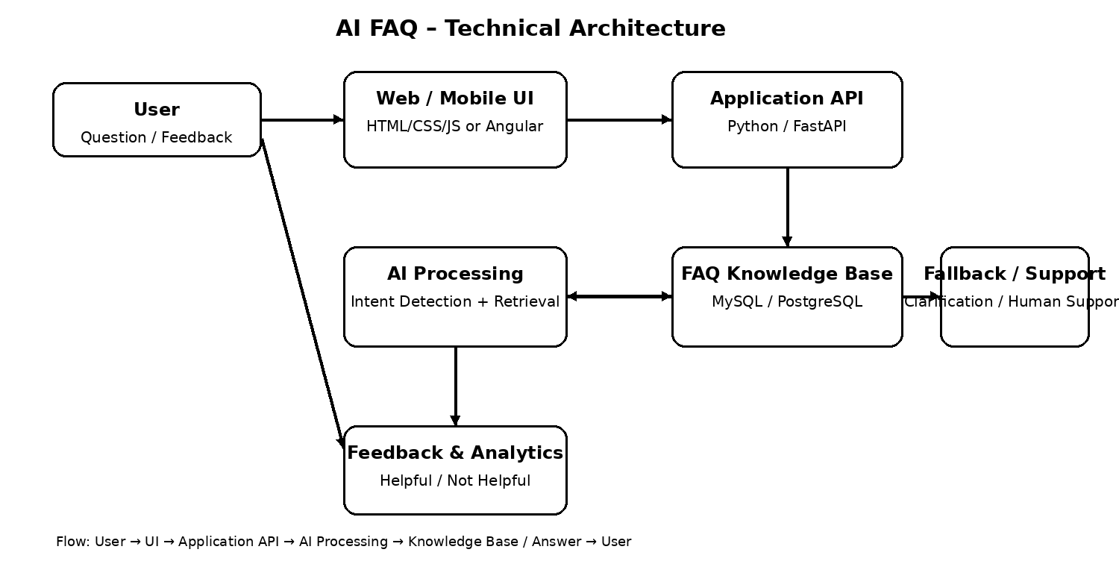
Table-1: Components & Technologies
S.No | Component | Description | Technology
1 | User Interface | Interface through which users enter questions, view answers, and provide feedback. | HTML, CSS, JavaScript / Angular
2 | Application Logic-1 | Handles user requests, validation, routing, and FAQ search requests. | Python / FastAPI
3 | Application Logic-2 | Detects the intent of the user question and prepares the query for retrieval. | Python NLP / Intent Detection
4 | Application Logic-3 | Generates or formats a concise response using approved FAQ content. | AI/NLP model or LLM API
5 | Database | Stores approved FAQ questions, answers, categories, and metadata. | MySQL / PostgreSQL
6 | Cloud Database | Optional managed database layer for scalable deployment. | AWS RDS / Azure Database / Cloud SQL
7 | File Storage | Stores supporting documents or FAQ source files when required. | Object Storage such as S3 / Azure Blob
8 | External API-1 | AI model service used for language understanding or answer generation. | LLM / AI API
9 | External API-2 | Optional support/notification service for escalation or user communication. | Email / Helpdesk API
10 | Machine Learning Model | Model used for intent classification, semantic matching, or retrieval ranking. | Embedding / Classification Model
11 | Infrastructure (Server / Cloud) | Hosts the UI, API, AI processing, database, and deployment services. | Local / Cloud, Docker, Kubernetes, or equivalent
Table-2: Application Characteristics
S.No | Characteristics | Description | Technology
1 | Open-Source Frameworks | List the open-source frameworks used to build the application and API. | Python, FastAPI, Angular / React
2 | Security Implementations | Authentication, authorization, secure API access, encryption, and input validation. | HTTPS, JWT/OAuth, IAM, encryption, OWASP practices
3 | Scalable Architecture | Architecture should support increasing users, questions, and knowledge-base size. | 3-tier architecture, containerization, load balancing
4 | Availability | Maintain service availability using health checks, backups, failover, and appropriate deployment configuration. | Cloud hosting, health checks, load balancer, database backup
5 | Performance | Reduce response time using efficient FAQ retrieval, caching, indexing, and suitable AI model selection. | DB indexing, caching, embeddings/vector search, CDN where applicable

AI FAQ Detailed Architecture
1. User Interface Layer: Provides a simple text box or chat-style interface. The user can enter natural-language questions, submit them, view answers, and mark answers as Helpful or Not Helpful.
2. Application / API Layer: Receives the question, validates the request, manages session information, and sends the query to the AI processing and FAQ retrieval components.
3. Intent Detection Layer: Identifies what the user is asking even when the wording differs from the stored FAQ question. Example: “How can I change my password?” and “I forgot my password, what should I do?” can map to the same intent.
4. FAQ Knowledge Base: Contains approved questions, answers, categories, keywords, and supporting information. This layer acts as the trusted source for responses.
5. AI Answer Layer: Selects or generates a concise answer using the retrieved approved content. The system should avoid inventing information that is not supported by the knowledge base.
6. Fallback / Human Support: When the question is unclear, unsupported, or confidence is insufficient, the system asks for clarification or directs the user to human support / an appropriate resource.
7. Feedback & Improvement: User feedback and logs of unanswered questions can be reviewed periodically to update the FAQ content and improve intent matching.
AI FAQ Content Mapping
FAQ Area | System Component | Expected Behaviour
What is the AI FAQ? | UI + API + Knowledge Base | Explain the purpose of the AI FAQ using approved project content.
How does it work? | Intent Detection + Retrieval | Detect intent, search approved FAQ content, and return the relevant answer.
What if the question is unclear? | Fallback Support | Ask the user to clarify the question.
What if there is no matching answer? | Fallback / Human Support | Return a safe fallback and direct the user to support or the correct resource.
Can the FAQ be updated? | Knowledge Base | Allow approved questions and answers to be added or updated.
How is answer quality improved? | Feedback + Review | Use feedback and unanswered-question analysis to improve content.
Technology Stack Summary
Layer | Technology
Frontend | HTML, CSS, JavaScript / Angular or React
Backend | Python + FastAPI
AI / NLP | Intent detection, embeddings / semantic search, LLM API where required
Database | MySQL / PostgreSQL
Vector Search (Optional) | FAISS, pgvector, or managed vector database
Cloud / Deployment | AWS / Azure / GCP, Docker
Security | HTTPS, authentication, authorization, input validation, secrets management
Monitoring | Application logs, API metrics, health checks, error monitoring
References
- AI FAQ project requirements and approved FAQ content.
- FastAPI documentation – https://fastapi.tiangolo.com/
- Python documentation – https://docs.python.org/
- MySQL documentation – https://dev.mysql.com/doc/
- PostgreSQL documentation – https://www.postgresql.org/docs/
- OWASP Application Security Verification Standard – https://owasp.org/
End of Document

